**AUDIO AND DATA TRANSFER THROUGH LIFI TECHNOLOGY**

Apurv kumar1,Anshita Yadav2,Mohd Anas3,Ranjeeta Yadav4

1,2,3,4,ABES Engineering College,Ghaziabad,UttarPradesh,India

**ABSTRACT**— Over the course of the before ten years, a lot of research has been done to look into other parts of the electromagnetic spectrum that are might be able to move a lot of network traffic from the overcrowded radio frequency (RF) domain. OWC, or optical wireless communication, is now a viable alternative to the issues that will arise as a result of the upcoming radio frequency RF spectrum crisis, particularly in certain locations and situations. Currently, indoors, where light fidelity and visible light communication (VLC) offer effective solutions to numerous wireless communication issues, the majority of mobile data traffic is consumed. This paper examines the VLC IEEE standard, its implementations, difficulties, data modulation methods, and LiFi's newly dubbed optical wireless communication technology in particular.

**Keywords-** Audio And Data Transfer, Embedded System , Arduino Uno, VLC

**1. INTRODUCTION**

Data is transmitted using leds in LiFi technology. It is derived from optical wireless communication technology that uses LED light to transmit information at a rapid rate. The Led is turned off and on very quickly for visible light communication, which is invisible to the human eye. The LiFi LED emitter maintains an intensity that is high enough to facilitate easy communication while remaining low enough to be invisible to the human eye. The LiFi LED emitter maintains a sufficiently low intensity to be indistinct to the human eye while remaining high enough to make communication simple. The light is very safe from hacking because it cannot penetrate the walls. However, this limits the range as well. This is advantageous in settings like hospitals, nuclear power plants, and aircraft that are particularly susceptible to electromagnetic interference.This is advantageous in environments that are particularly susceptible to electromagnetic interference, such as aircraft, nuclear power plants, and hospitals. Although both WiFi and LiFi transmit data using the electromagnetic spectrum, LiFi uses visible light and WiFi uses radio waves. Li-Fi has virtually no capacity limitations.While WiFi and LiFi both use radio waves to send data, LiFi uses visible light. The electromagnetic range is utilized by WiFi.Li-Fi has virtually no capacity limitations. The radio frequency spectrum is 10,000 times smaller than the visible light spectrum. The light signals are received by the receiver through wireless channels. In order to recover the message, the optical signals are converted by the detector in the receiver. Physical space can be used to protect LiFi signals because light cannot pass through the walls.The receiver's detector converts the optical signals so that the message can be recovered. Because walls prevent light from passing through them, LiFi signals can be protected in physical space.

As an alternative method of data transfer, VLC is a brand-new technology that provides increased data rates and security.

**2. LITERATURE REVIEW:**

[1] This paper discusses wiring harnesses, which combine control and communication wires. The lamp, wiper, and fan assembly wiring harness was successfully replaced, resulting in a 67% weight reduction.

[2] The fact that the architecture of the new 5G cell towers is so different from that of the ones that are compatible with today's 3G and 4G mobile networks is the source of most of the concerns regarding 5G's alleged negative effects on health. Light fidelity (Li-Fi) is therefore the best option for meeting the requirements of smart cities and achieving a high data rate. Li-Fi is able to handle the large number of users required for Internet of Things (IOT) connectivity.

[3] In this paper the Li-Fi has ten thousand times more control over the visible light spectrum than radio waves do. It uses visible light to transmit instead of radio waves.

[4] Sensors that monitor the human body include those that record respiration, blood pressure, and heartbeat. The PIC16F877A modifies it by converting it to digital form, which is then input into the Li-Fi module that communicates information in light form. The camera sensor's light is picked up by the receiver. The information is then visually displayed on the computer.

[5] Li-Fi also has a smaller environmental impact due to its use of the visible light spectrum. As is known, the visible light spectrum had very little effect on other organisms like plants, animals, and their ecosystems. As a result, Li-Fi is regarded as a "greener" yet more effective technology due to the fact that it provides greater security, lowers power consumption, and has a lower impact on the environment.

[6] In this project, a limited scale Li-Fi framework that can be utilized for short-range teleoperational control of a submerged vehicle is the focal point of this task. This control can be provided by a communications relay from surface-based support or by a diver working in close proximity to the robot.

[7 Li-Fi is a method of transmitting data at extremely high speeds that makes use of the electromagnetic spectrum's visible light portion.

[8] With the help of readily available light sources, the system transfers data at a faster rate without the need for RF-dependent technologies. Voice-Activated Li-Fi Operated Surveillance makes use of a speech recognition algorithm and Li-Fi technology as a wireless medium to perform machine movements in response to the operator's voice.

**3. PROPOSED WORK**

Visible light is a new technique of data transmission method.

Li-Fi, data is transmitted by modulating the intensity of the

light, which is then received by a Photo-sensitive

detector.VLC, consists of a light source as a transmitter and

detector as a receiver. Louder the voice, the glow of the LED

will be more. The receiver section interprets the incoming

light which is detected using a solar panel and converts to

the audible sound signal with the help of Speaker. Hence

with Li-Fi this method is made sophisticated by using more

than one LED and passing more than one data stream at a

given time. This way more information can be passed and

hence a faster data communication is possible

Visible light is a new technique of data transmission method.

Li-Fi, data is transmitted by modulating the intensity of the

light, which is then received by a Photo-sensitive

detector.VLC, consists of a light source as a transmitter and

detector as a receiver. Louder the voice, the glow of the LED

will be more. The receiver section interprets the incoming

light which is detected using a solar panel and converts to

the audible sound signal with the help of Speaker. Hence

with Li-Fi this method is made sophisticated by using more

than one LED and passing more than one data stream at a

given time. This way more information can be passed and

hence a faster data communication is possible

Visible light is a new technique of data transmission method.

Li-Fi, data is transmitted by modulating the intensity of the

light, which is then received by a Photo-sensitive

detector.VLC, consists of a light source as a transmitter and

detector as a receiver. Louder the voice, the glow of the LED

will be more. The receiver section interprets the incoming

light which is detected using a solar panel and converts to

the audible sound signal with the help of Speaker. Hence

with Li-Fi this method is made sophisticated by using more

than one LED and passing more than one data stream at a

given time. This way more information can be passed and

hence a faster data communication is possible

Visible light is a novel method for transmitting data. Data is sent in Li-Fi by adjusting the brightness of the light, which is picked up by a photosensitive detector. In VLC, a light source transmits and a detector receives information. The LED will glow brighter the louder the voice. The solar panel-detected incoming light is interpreted by the receiver section, which then transforms it into an audible sound signal with the assistance of a Speaker. As a result, this method becomes more sophisticated to Li-Fi's use of multiple LEDs and multiple data streams at a given time. This method enables faster data communication by transmitting more information.A Li-Fi trans-receiver’s fundamental operation.It transmits an electrical signal to an LED driver from an input device.The photodiode receives this electrical signal in the form of light as binary data.After that, the light signal is recognized by the receiver, and the data that is sent to the output device is decoded. In our project, laser light is used to send audio and data to the solar panel for audio signal transmission, the positive end of the laser is connected to a 5 volt supply;An audio device's aux cable is connected to the laser's ground end;The signal's amplitude changes are send to the solar panel, and the solar panel's output is connected to an amplifier circuit that is connected to the speaker for the purpose of transmitting data, the laser source is connected to the Arduino Uno microcontroller the text data is converted into digital output for the solar panel in the forms of 1 and 0.On the receiving side, the analog pin of the Arduino uno is connected to the solar panel's analog output.

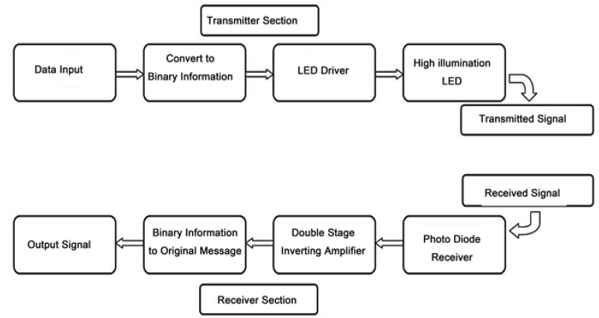

Fig 1 Block Diagram for proposed system

**4. METHODOLOGY**

Text, images, videos, and audio signals can all be sent using Li-Fi. And also it can be used to provide internet access. The transmission of two types of data is the primary focus of this paper: text and audio waves Topologies, as well as there are many different features and variations of the data that are being sent from various setups.Audio signals have been sent from one source to one output (SISO), multiple sources to multiple outputs (MIMO), and one source to one output (MISO). Using an arrangement of Arduino boards, a L.E.D., and a Silicon photo-diodewe were able to transmit text between two users.

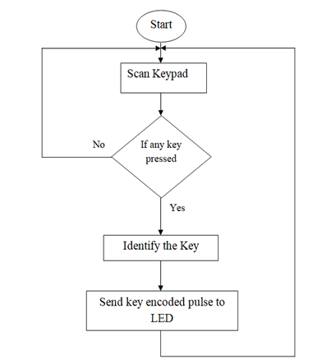

Fig 2.1 Transmitter Flow Diagram

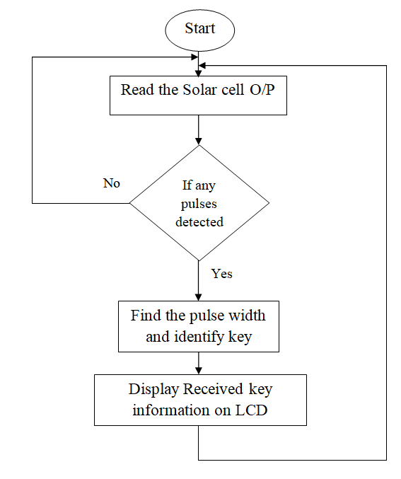

Fig 2.2 Receiver Flow Diagram

AUDIO SEGMENT

The audio signal was sent through the 3.5 mm jack from the phone at the transmitter end, transforming the digital signal into an analog signal. This analog signal is amplified before being sent to the breadboard-connected LED array. A power supply is also provided for the LED array.This power comes from a 9V battery that is connected to the LED array and the 3.5 mm jack. A photodetector-functioning solar panel captures this variation in light intensity. The received signal is sent to the speaker that has been pre-amplified. and records all variations. Using the same concept, an analog phone signal was substituted for text-to-speech software.

TEXT SEGMENT

The text transmission segment consist of three parts. The first is Arduino sends text to itself. Second, sending text between two Arduinos via infrared. Thirdly, text communication between two Arduinos via VLC.The transmission of data through LEDs is the fundamental principle of Li-Fi. When used as a light source, LED bulbs can transmit data through visible light at constant current. LED flickering has an impact on the transmission speed as well as the flow of data. When data is transmitted, this LED turns on, and when zero is transmitted, it turns off. Variable light frequencies encode the data and strings of one and zero turn the LEDs ON and OFF, respectively.A Li-Fi trans-receiver’s fundamental operation.It transmits an electrical signal to an LED driver from an input device.The photodiode receives this electrical signal in the form of light as binary data.After that, the light signal is recognized by the receiver, and the data that is sent to the output device is decoded.In our project, laser light is used to send audio and data to the solar panel.For audio signal transmission, the positive end of the laser is connected to a 5 volt supply;An audio device's aux cable is connected to the laser's ground end;The signal's amplitude changes are sent to the solar panel, and the solar panel's output is connected to an amplifier circuit that is connected to the speaker.

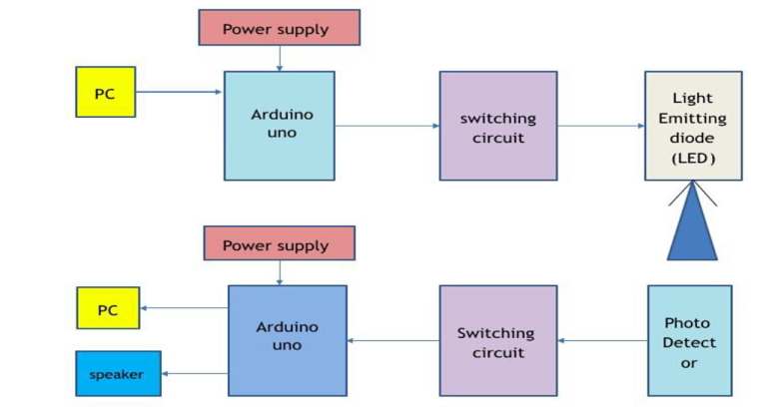

Fig 3 Block Diagram of Transmitter and Receiver Section

**5. WORKING**

The whole system consists of 3 parts. (1) Transmitter end, (2) Receiver end, (3) Transmission medium.

(1) **Transmitter End:** The transmitter consists of a PC with a keyboard and an Arduino. The input is given through the keyboard (example: AbCdE). The Arduino (1) converts the text into 8 bit binary. A UART must add sync and parity bits to the data packet on the transmit side before sending it through the transmission line with a laser beam at the right time.

(2)**Transmission medium**: The transmission medium is nothing but air. After transmitting, the information containing laser travels through the air and incident upon the solar panel of the receiver.

(3) **Receiver End:** The receiver contains a small solar panel, an Arduino and a PC with a monitor. When the laser beam is incident on the solar panel, it converts the data containing light signal into a current and this current flow through the Arduino (2). This Arduino converts the bits into corresponding alphanumeric characters and the computer monitor shows them. This is our desired output. At the transmitter end, the audio signal was transmitted via a smartphone, which provided the signal through the 3.5 mm jack. Both the phone's input audio and the 3.5mm audio jack undergo analog conversion. There are typically three output lines on a 3.5mm audio jack: ground, right, and left . The left and right audio output signals are connected to the negative terminal of the 9V battery.The negative of the LED array that is connected to a breadboard serves as the ground for the 3.5mm jack, and the positive of the 9V array serves as the ground for the resistors that are connected in series with the LED array. Based on the effective voltage difference, The carrier wave produced by the LEDs is effectively manipulated by this circuit. The changes happen quickly and are hard to see with the naked eye.

**6 HARDWARE IMPLEMENTATION & CIRCUIT** 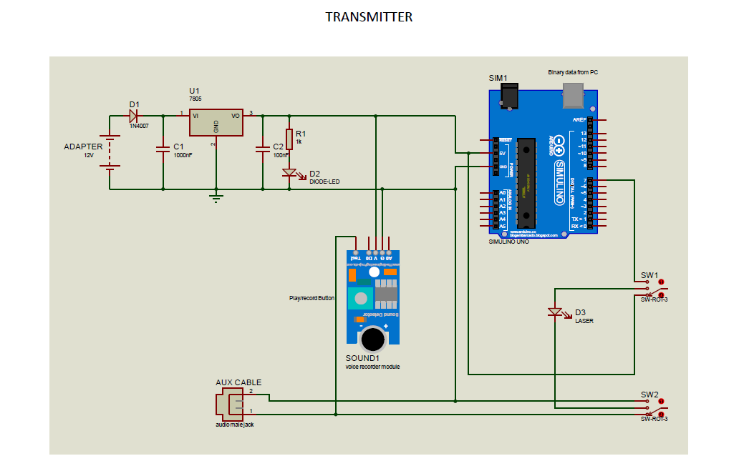 Fig 4.1Circuit Diagram of Transmitter Section

For Audio signal transmission , the positive end of laser is connected to 5v supply , ground of laser is connected to aux cable to audio device , the signal amplitude flucatuation are transmitted to solar panel , the solar panel output is connected to amplifier circuit i.e connected to speaker. At the sending end, Arduino-1 is used to convert the alphanumeric characters into 8 bit ASCII code. For the code, we have to do the followings: Take the characters as input and Convert the characters into ASCII code of which the start bit is 1 The delay is set 10ms between two consecutive bits Set the delay of 100ms between two consecutive Bytes. Then Upload the code. The phone's built-in digital to analog converter is used to transfer the digital music file to the audio jack, which is located here. The audio jack is connected in series in the transmitter circuit, which is powered by a power supply circuit. If it starts playing a song, it will send the data through the LEDs, but it doesn't have the speaker circuit hooked up yet, so it can't tell if it's being sent because the LEDs change too quickly for the eye to see.

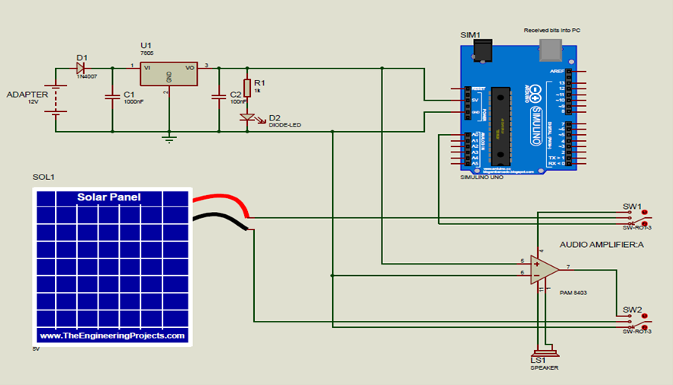

Fig 4.2 Circuit Diagram Of Receiver Section

For Data transmission laser source is connected to Arduino uno microcontroller , the text data is converted to digital output in 1 , 0 forms to the solar panel . At receiving side solar panel the analog output of Arduino uno , then the output charater data is taken out via serial monitor. Laser light is sent to the solar panel and solar panel now receives the data. The solar panel is connected with the A0 pin and ground. After checking the value of the solar panel using built in “AnalogReadSignal” both when there is no light on the laser, and when there is light on the laser. We then set the THRESHOLD Value for the solar panel by examining the value from “AnalogReadSignal”. In setup, we consider the solarpin A0 as input and fix the Serial.begin to 9600. Then we take the reading from the solar pin. If the Reading from the solarpin is greater than the threshold, then we consider it to be ‘1’, otherwise it is considered as ‘0’.

**7. RESULT**

The results obtained for the research work are been discussed as follows.

A. Audio Transmission

We were able to transmit audio, in this case music from a smartphone, by connecting three three-volt LEDs in series with a 220 ohm resistor for 0.5 feet. The music signal can be heard for one foot if there are no outside light interferences. A summary of the model is provided in Figures 5 and 6.

Step1: When the audio is received initially through a 3.5mm jack, the LEDs begin to blink.

Step2: When LED blink it can send the data to a solar panel in front of them that picks up the changes in light and sends an amplified audio signal to the receiver.

B. Text Transmission

Using a li-fi module that is a part of the Arduino Nano microcontroller and a serial to USB converter for text to speech conversion, text was sent between two laptops.At a distance of three feet from the transceiver, the text can be transmitted here up to 100 characters if there is no interference. The model is presented in its entirety in Figure 7.

Step1: An input message is initially entered into the Arduino IDE on the transmitting laptop. The message reads, "Good Morning, Welcome to ABES Engineering College,".

Step2: The "RUNNING" message is displayed on the screen when the Arduino IDE program is run on the receiving laptop. We now receive both an audio and text message that reads "Good Morning Welcome to ABES Engineering College " on the screen after the input message has been sent to the transmitter, as is represent in Fig. 8.

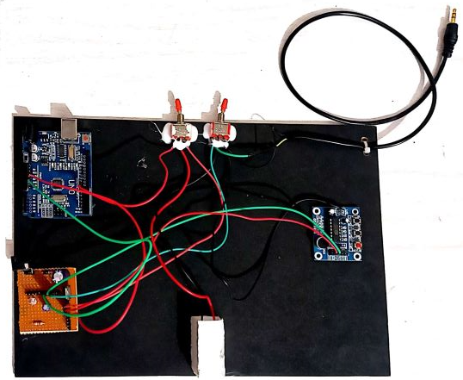

Fig 5 Transmitter Section Model Overview

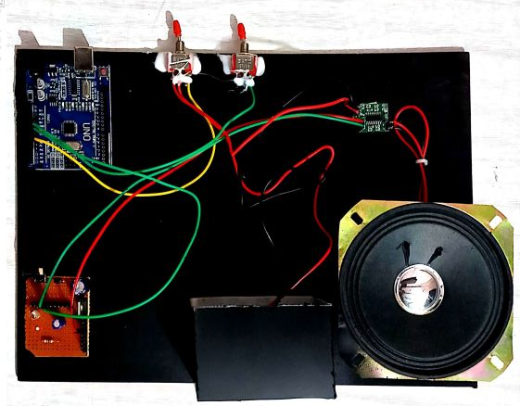

Fig 6 Receiver Section Model Overview

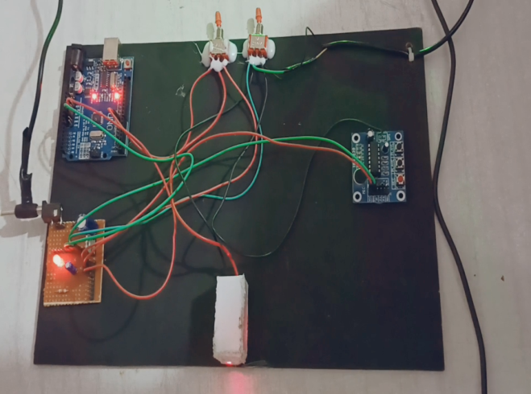

Fig 7 Text Transmission Model Overview

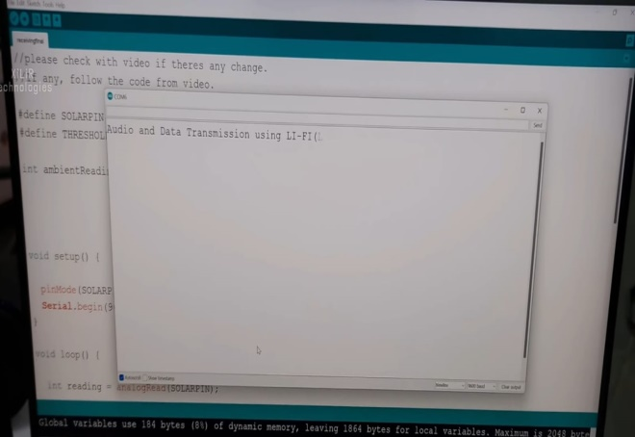

Fig. 8: Message is received by the receiver and played.

**8 .CONCLUSION**

Every light bulb can serve as a Wi-Fi hotspot for wireless data transmission if this technology is implemented, and our future will be cleaner, greener, safer, and brighter. Li-Fi is currently receiving a lot of attention due to the possibility of providing a genuine and highly effective alternative to radio-based wireless.The airwaves are becoming increasingly congested as a result of the increasing number of individuals and devices. using wireless internet, making it increasingly challenging to obtain a fast, dependable signal. This could help with problems like a lack of radio-frequency bandwidth and make internet possible in places like airplanes and hospitals where traditional radio-based wireless is prohibited. In this paper, a continuous sound transmission model is made with commercial LEDs; It is anticipated that commercial LED lamps will make it possible to transmit information over longer distances. High-quality audio can be transmitted over a one-millimeter distance with the addition of Focusing lens between transmitter and receiver, International Journal of Pure and Applied Mathematics, Special Issue 184.

**9. FUTURE SCOPE**

Li-Fi is a brand-new technology with a lot of promise. There is a lot of room for research in this area. In this area, a lot of scientists are already doing a lot of research. Li-Fi's future lies in Gi-Fi. Wireless communication that transmits data in excess of one billion bits per second (gigabit) is referred to as "gigabit wireless" or "Gi-Fi." By using Li-Fi, parallelism can save energy. In the not-too-distant future, we might be able to put in place an LED array next to a motorway.

**10. REFERENCES**

1. T.Komine and M. Nakagawa, ”Fundamental analysis for visible light communication systems using LED Lights, ”IEEE Trans. Consumer Electronics, vol. 59, no.1, Feb, 2004.
2. S. Schmid, G. Corbellini, S. Mangold, and T.R.Gross,“Led-to-led visible light communication networks, ” in Proceedings of the fourteenth ACM international symposium on Mobile ad hoc networking and computing. ACM, 2013, pp. 1–10.
3. Online International, 2016: "High sensitivity universal Lifi receiver for enhanced data communication," by Zashi P. Choudhari and Satish R.Devane Conf. on Green Engineering and Technologies (ICGET) ISBN 978-1-5090-4556-3/16/31.00 IEEE
4. S. Rajagopal, R. D. Roberts, and S.-K. Lim, “Ieee 802.15. 7 visible light communication: modulation schemes and dimming support, ” Communications Magazine, IEEE, vol. 50, no. 3, pp. 72–82, 2012.
5. Mesleh, R., Elgala H.and Haas, H., ―Indoor Optical Wireless Communication: Potential and State-of-the- Art, ‖ IEEE Commun. Mag. 49, 56–62 (Sept. 2011).ISSN: 0163-6804.
6. Rohan Kapoor, Allesandro Gardi, Roborto Sabatini “A Multistatic Ultrasonic Navigation System for GNSS-Denied Environment AIAA Scitech 2019 Forum, 2019.pp.1930.
7. D. Andrade, J. P. Gomes, and P. S. André, "Execution of a Noticeable Light Correspondence Connection: Smartphone Li-Fi DOI: "2019," 10.9790/2834-1703015258 www.iosrjournals.org 58 | Page Detection.
8. M. D. Soltani and Associates, Bidirectional optical spatial modulation for mobile users: Towards a Practical LiFi System Design," IEEE Selected Areas in Communications, vol. 37, no. 9, pp. 2069- 2086, 2019.
9. D. Ramananda, A. M. Sequeira, S. R. Raikar, and C. K. Shanbhag's "Design and Implementation of LiFi Communicatio system" in the IOP Conference Series: 2019, vol. 594, no. 1, Materials Science and Engineering 1, p. 012041: IOP's publishing
10. H. Haas and co., Introduction to the concepts and difficulties of indoor networking in LiFi," Journal of Optical Communications and Networking, vol. 12, no. 2, pp. A190-A203, 2020.
11. The ns-3 network simulator," by G. F. Riley and T. R. Henderson, in Modeling and tools for network simulation: pp. Springer, 2010. 15-34.
12. Sapna Mamidkar, Rasmiranjan Samantray “A Survey on Li-Fi Technology and Its Applications” Archived from International Journal of Science and Research Volume 7 Issue 7 pp;1388-1392 July 2018.
13. "A performance study of various mobility speed on AODV routing protocol in homogeneous and heterogeneous MANET," by Z. Ismail and R. Hassan, is published in IEEE The seventeenth Asia Pacific Gathering on Correspondences, 2011 637-642.
14. Li-Fi (Light Loyalty) - An Outline to Future Remote Innovation in the Field of Information Correspondence," by Gurpinder Singh, published in November 2015.
15. Mrs. M. Prathibha, M. Sharmila, M. Shrin Shifana,V.Theebica,and V. Sangeethapriya's audio transmission over a lifi system in April 2018.